Zhihua Shang

05/18/2020

Fundations of Programming(python)

Assignment05

Work with Dictionary and Files

# Introduction

Python is a very powerful tool to improve work efficiency. It is a very important job skill in the workplace. When people work as a group, they need to check and add information to others’ work. In this script, it shows some dictionary and update codes of a file.

# Create a folder and Open the downloaded file

Open file via PyCharm. Click create new project, name it as Assignment05, and save it under _PythonClass in C: drive, then open and find the location where you have downloaded the Assginment05_Starter.py (Figure 1).

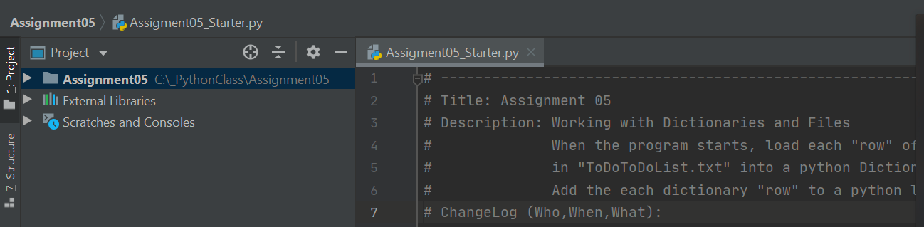

*Figure 1: Showing the location of Assginment05_Starter.py*

# Coding

This is the main and the most important part of the whole process because it would not work if the codes are wrong. The first step is to read the existing code and check where the codes should be updated, then fix it. This part shows the steps and some pictures to demonstrate the results.

## Update the changelog in the header

A header is very important for both the creators and other users. It provides some basic information about this script. For example, the title, the creator, and the created date. Some codes will be update in this script, so the changes notification could be added to the header (Figure 2).

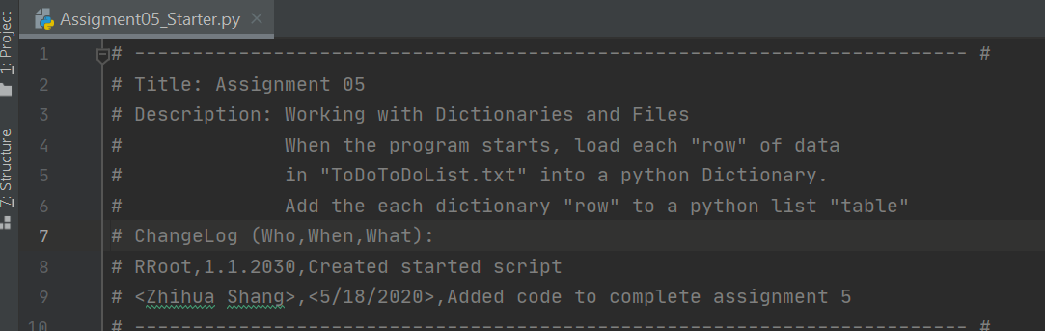

*Figure 2: Showing the updated changelog of file.*

## Update step 1

Step 1 needs to be updated. When the program starts, reading a row of data from a text file and adding it to a dictionary (Figure 3).

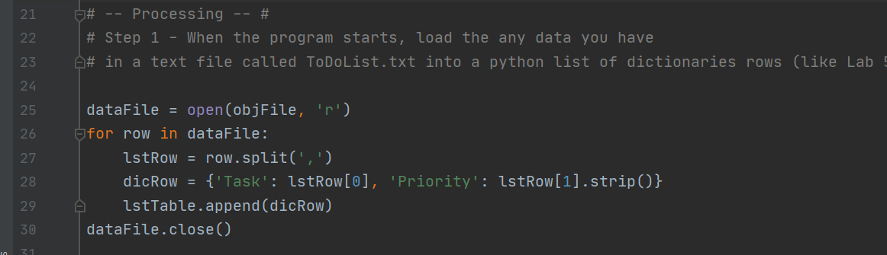

*Figure 3: Showing the updated step 1 of file.*

## Update step 2

No data can be updated in this step.

## Update step 3

This step is to show the current items in the table. First, it is better to print a header so that the user will know what it is about, then use for loop to show each item of the dictionary from this list table (Figure 4).

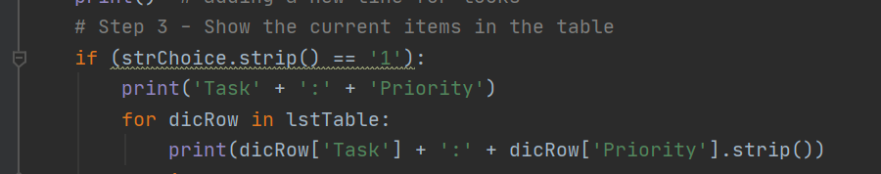

*Figure 4: Showing the updated step 3 of file.*

## Update step 4

This step is a add a new item to the list. Input() function can be used to capture the user’s data, then put the input to the dictionary and append to the list (Figure 5).

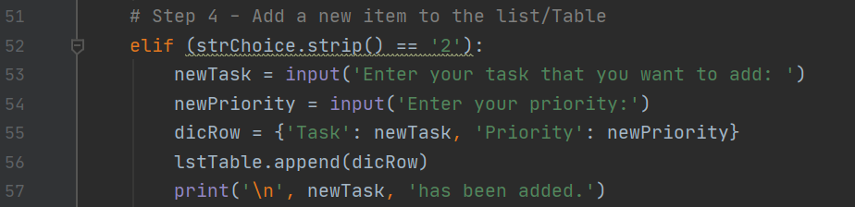

*Figure 5: Showing the updated step 4 of file.*

## Update step 5

Step 5 is to remove a new item from the list. A input() function is used to chapter the user’s data that they want to remove. In order to find the item, lower() function could be used to match the data that would be removed. Meanwhile, a list remove() function is used to delete the part of data (Figure 6).

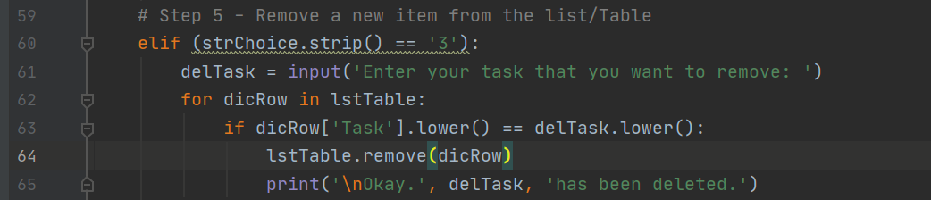

*Figure 6: Showing the updated step 5 of file.*

## Update step 6

This step is to save the task to a specific .txt file. In this case, it is called ToDoToDoList.txt file which can be wrote inside the open() function directly, and ‘w’ means that the data can be saved in the file. Each item of the dictionary includes a key and a value, which is ‘Task’ and ‘Priority’, respectively. After that, close the file (Figure 7).

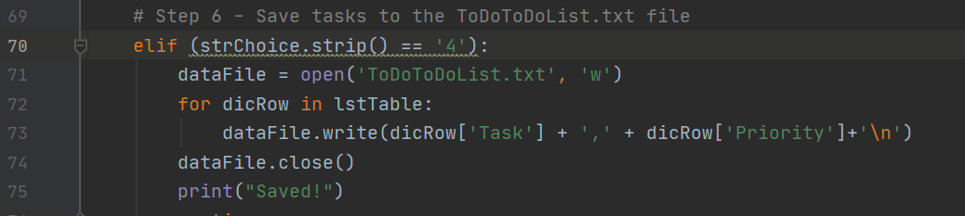*Figure 7: Showing the updated step 6 of file.*

After running this step, the text file can be found next to the python file (Figure 8).

. 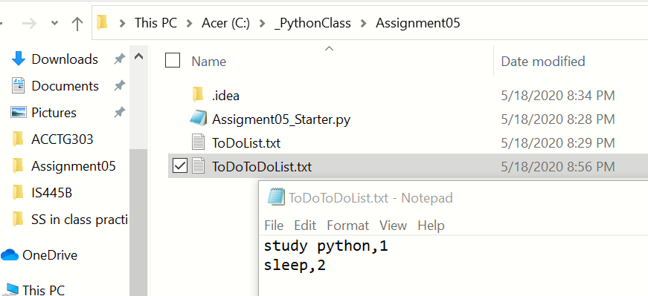

*Figure 8: Showing location of the ToDoToDoList.txt.*

## Update step 7

Step 7 is just to exit the program. Sometimes, users change their mind. It is very helpful to ask a question to make sure the users’ choices (Figure 9).

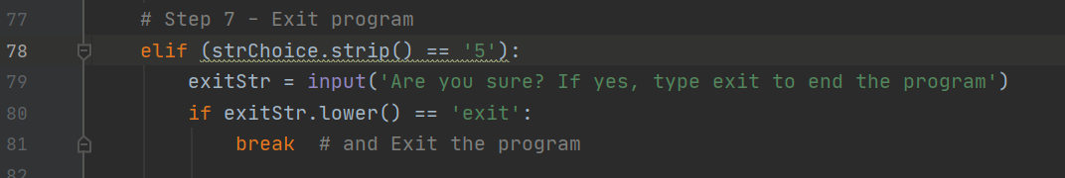*Figure 9: Showing the updated step 7 of file.*

## Demonstrate in PyCharm

This is the result that showing in PyCharm (Figure 10).

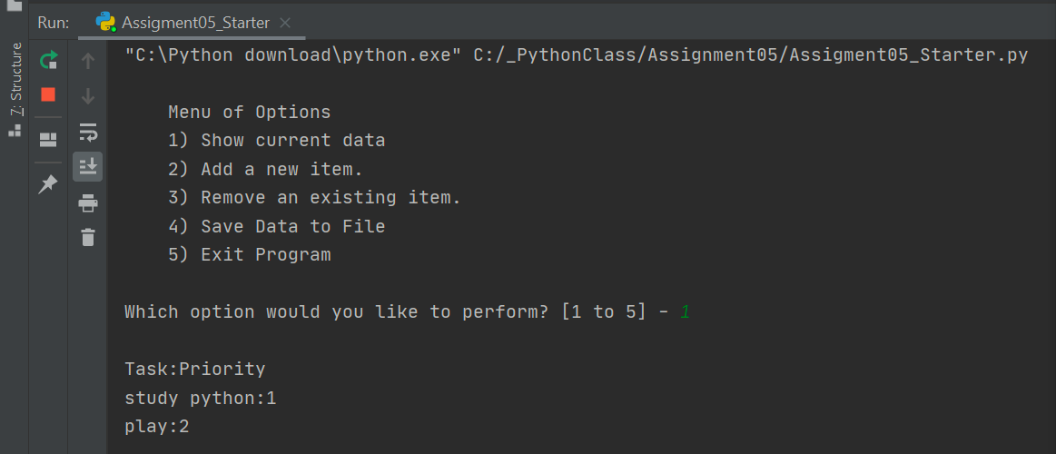

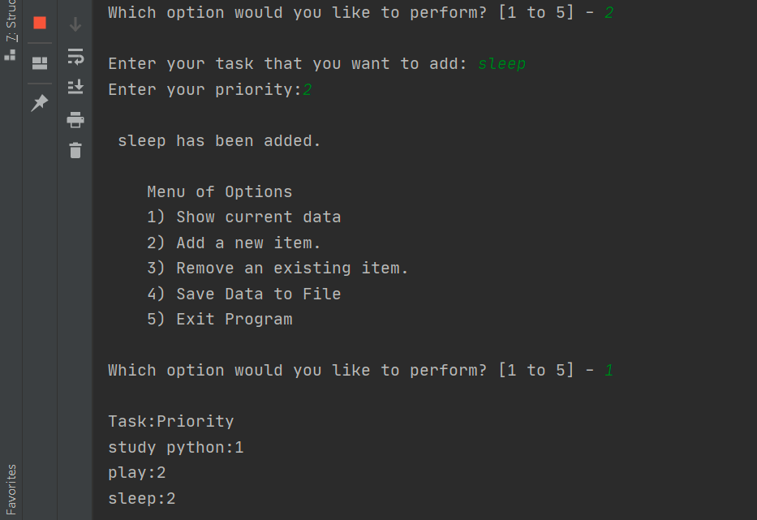

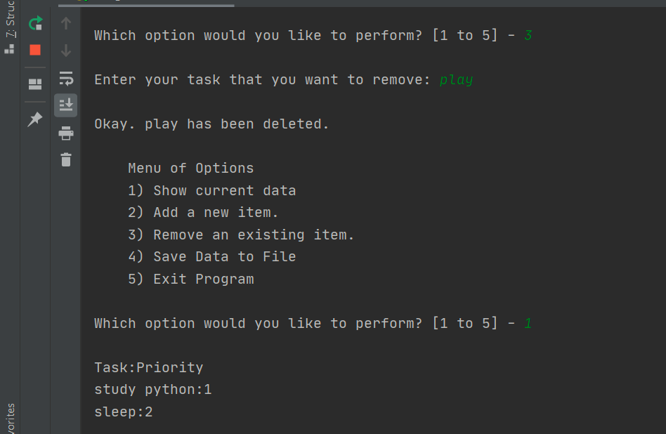

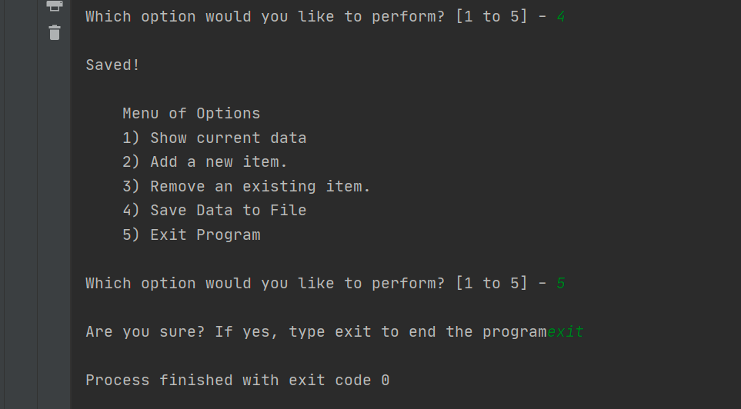

*Figure 10:* *Python script running from PyCharm.*

## Demonstrate in Shell window

Beside working in PyCharm, the same script could also be demonstrated in IDEL shell. Go to start, search and click IDEL. The shell window shows up. Find file and open from the Assignment05 which is under_PythonClass in C drive. Run it, and the same result will be shown (Figure 11).

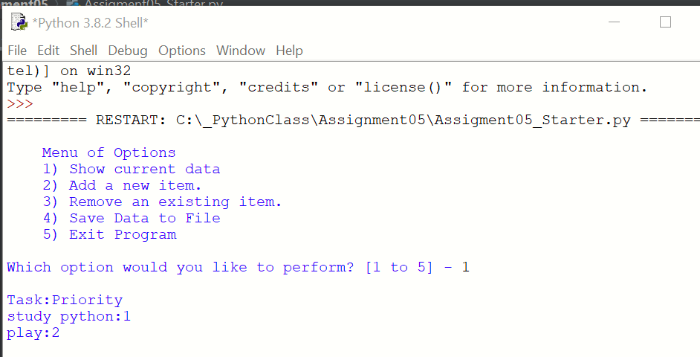

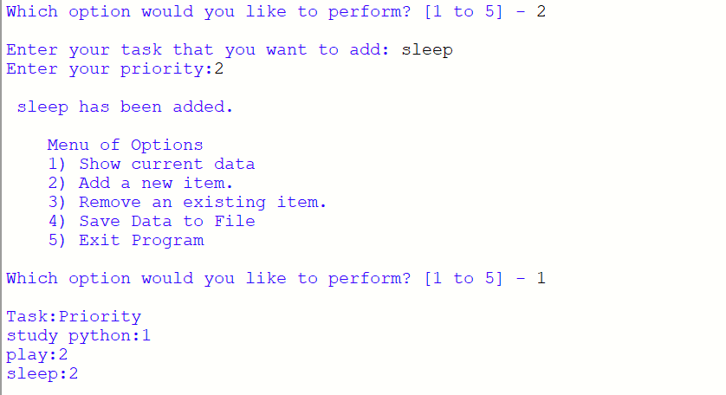

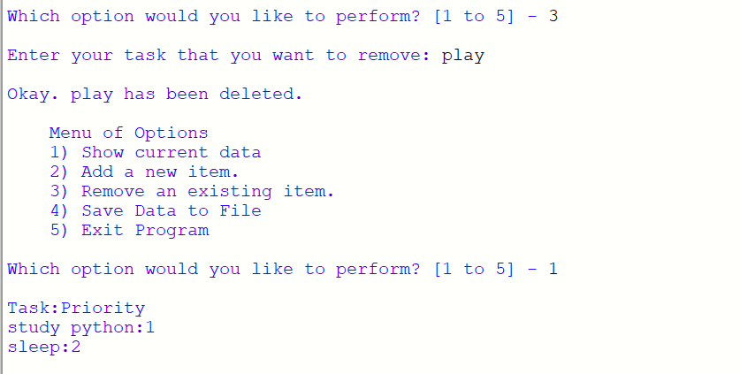

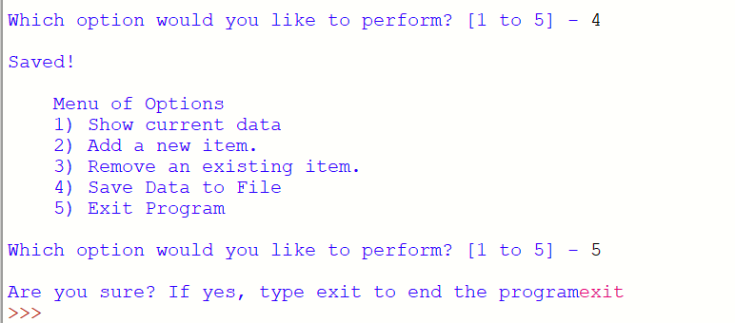

*Figure 11: script running from Shell window*

# Summary

Both list and dictionary are very useful tool to deal with database. Python with these two functions enable people to work efficiently by just writing some lines codes.